**There is a teacher shortage in Australia**

Is there a teacher shortage in Australia? The Answer is a clear-cut yes! The Australian education sector is currently grappling with this critical challenge, due to which the need for educators has become increasingly evident. As a result, the demand for quality education has also shot up in the recent years. The 2021 Census has emerged as a valuable resource, providing comprehensive data on the number of students in primary, secondary and other education as well as insights into the workforce within the education sector. I have conducted a detailed analysis as to how and what causes the shortage of education professionals in Australia, across Geolocations and Type of Education. The below given graph clearly depicts the shortage of teachers across Education Type.

This blog post explores the intricate relationship between education professionals, students, and schools, focusing on a geographical level defined by postcodes and LGA regions. Leveraging the dataset from the 2021 Census and complementing it with information sourced from the Australian Curriculum, Assessment and Reporting Authority (ACARA) on all Australian schools, the objective of this blogpost is to shed light on the nature of education professional-student-school ratios across the nation. By analysing these ratios at a fine-grained, postcode and LGA-based level, we aim to achieve several key objectives like understanding current trends, the reasons for the shortages, and considerations that needs to be taken up on priority while making informed decisions.

**Trend as per Government and Non-Government Sectors**

To begin with our analysis, we studied trends between the student population and Teacher population in Australia. Instead of studying the data based on Postcodes, it was decided to use LGA (Local Government Administration). The assumption behind this action was that not every teacher living in a particular postcode works in the same, as a certain percentage of teachers might be travelling to other destinations for work. In addition to that, that dataset also had information on the Type of Education, the Sector, and the Geolocation.

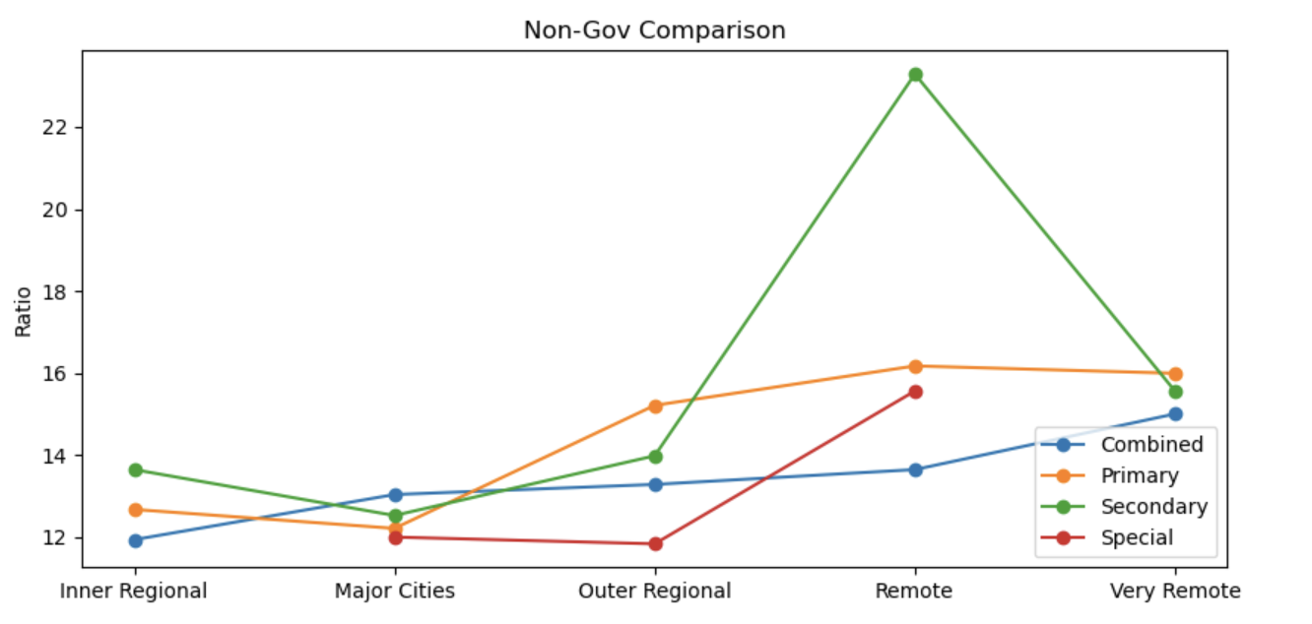

**(Note- The y axis represents the ratio of Student to Teacher population)**

As the graphs depicts, the Y-axis represents the ratio of Student Population to Teacher Population, while the x-axis represents the different types of Geolocations across Australia. The increase in the y-axis indicates the increase in the shortages of teachers with every datapoint. It was interesting to find that there are no special schools in ‘Very Remote’ areas and there are more Secondary schools in ‘Remote’ areas than primary, even though the overall number of Primary Schools are more than secondary across Australia. Hence, it would suffice to claim that Government Secondary schools faces the highest teacher shortages. The below-given map of Australia depicts the remoteness of area and clarifies the actual locations of inner-outer regions, major cities, and remote-very remote areas.

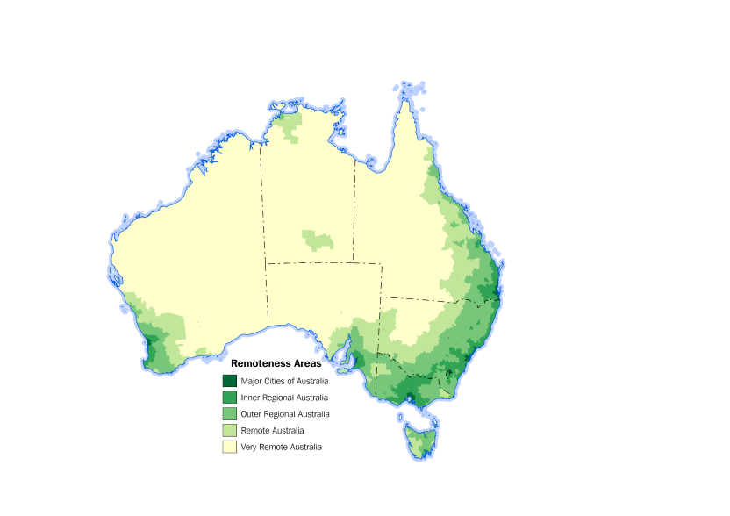

**Teacher Shortage as per Type of Education**

This box plot intends to show student-teacher ratio across Australia. The points that are appear as dots in the boxplot are outliers, as they go against the normal distribution of students-teacher ratio, with an average mean value of 15.09.

The upper whisker value stands at 30.32 and any value above upper whisker value is considered to be an outlier. The below given graphs considers **the outliers only** and shows what ‘Type of Education’ has the highest number of teacher shortage in the country.

Trend across Australia Trend in NSW

The above-given graph further breaks down the previous graph and depicts the shortage of teacher in NSW and compares it with the rest of Australia. It shows that Primary Schools have recorded a massive teacher shortage, compared to combined, secondary, and special schools. However, it was also interesting to note that most of these schools are in New South Wales, as nearly, 1/3rd out of all the schools that face teacher shortage in Australia were found to be in the most populous state of Australia. (Note- The y-axis stands for the student-teacher fraction). As the fraction increases, the number of students per teacher also increases.

**Why is Australia facing a teacher scarcity?**

The reason why Australia is currently facing a shortage of teachers is primarily because the professionals working in this sector are underpaid and the below given graph gives us an idea why.

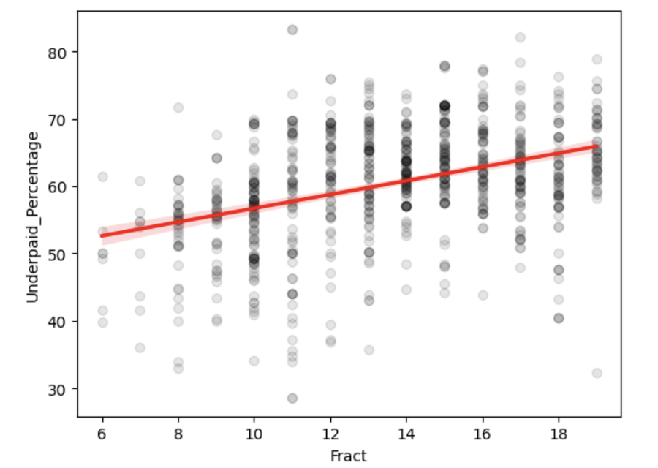

The graph shown above indicates that a positive relationship exists between the student:teacher ratio and the percentage of underpaid teachers in LGAs. In other words, as the fraction representing the student population to teacher population increases (meaning there are more students per teacher), the percentage of underpaid teachers in that area also increases. This suggests that teachers are more likely to feel underpaid and dissatisfied in regions where they must handle larger class sizes, which aligns with the idea that the underpayment issue is contributing to the shortage of teachers.

The student: teacher ratio remains an imporatant metric in education, which is why it directly impacts the quality of education that students receive. When this ratio is high, it means that there are more students per teacher, which can make it challenging for educators to provide individualized attention and support to each student. As a result, this may lead to a perception among teachers that their workload is too high, and their compensation is inadequate for the demands placed upon them. However, it's essential to recognize that the relationship described here is a correlation, and correlation does not necessarily imply causation. While the data may indicate a link between student-to-teacher ratios and teacher underpayment, there could be other factors at play. For instance, high student-to-teacher ratios might be more common in economically disadvantaged areas where teacher salaries are lower due to various socioeconomic factors.

To validate the relationship between Income and Teacher Scarcity in the Local Government Area and their postcodes, we conducted a hypothesis testing (Null Hypothesis- No teacher shortage; Hypothesis- There is a teacher shortage). The intention behind using this test was to confirm how strongly Student-Teacher ratio and Underpaid percentage of teachers are related. For the hypothesis testing, we used the p value for our inferences. On conducting the Pearson coefficient test, we got a coefficient value of 0.39 and a Pearson value close to 0. (Closer the value is to 0, the stronger is the correlation). This concludes that there is a strong association between the two and that we can reject the nu-ll hypothesis which states that there is no correlation.



**Predicting income-ranges for a specific LGA**

We used a classification model to predict the average income in a particular LGA region of a certain type of school. The features that were used for the testing was ‘LGA Region’, ‘Type of School’, ‘Number of Schools’, and ‘Number of Teachers’ to help supplement the prediction. For this scenario, we used the K-neighbours classification to determine which income range are prominent in a specific LGA.

We used the data to not only train the data well with a significant chunk but also helps us validate the model against our prediction. Numeric values were assigned to the income ranges, i.e., 0 represents 0-1000 AUD income range, 1 stands for 1000-2000 income ranges and 3 symbolizes 2000 and above income bracket. After training, we used the model to predict on the test data and validation was done using a classification report and accuracy score metric. The accuracy of the model stood at 99.07 percent and is performing best at K value of 1. With the help of the model, we can easily predict an income range of a particular LGA code. To further affirm the findings, a 3x3 confusion matrix was created. The confusion matrix gives the true values against the predicted value and gives us an idea of how good the model is performing.

**Confusion matrix heatmap**

In conclusion, we can affirm that the reason why there is an existing teacher scarcity in Australia is because they are widely underpaid. One of the main reasons behind educators being underpaid could be because of increasing number of young graduates not choosing to be an education professional, given the current trend of low income offered to them. The major objective established in this analysis is the trend depicting the student-Teacher ratio in Type of Education across Geolocations. Another interesting insight noticed through the analysis was shortage type of education (primary, combined, special and secondary).